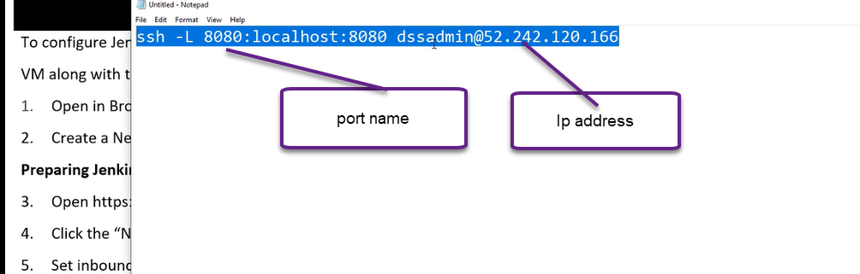

Jenkins is going to connect ip address of VM

It will create the VM in linux O.S for Jenkins

Sudo is a super user and cat is a command which will execute it.